**Documentation on Phone Book Application**

**Asp.Net MVC Application Components:**

1. ASP.NET Core Library

* Model Class
* DB Context Class
* Data Access Interface
* Data Access Layer Class

1. ASP .NET Core MVC

* Controller
* Views

**PhoneBook Application includes following features:**

* Displaying Admin Details
* Adding a new contact
* Deleting a contact
* Updating a contact
* Displaying all the contacts Details

**Workflow :**

1. **Index Page**

The information about the admin of the application is displayed in this page of the application. It provides information like ID, First and Last Names, Gender, DOB, and a variety of other characteristics.

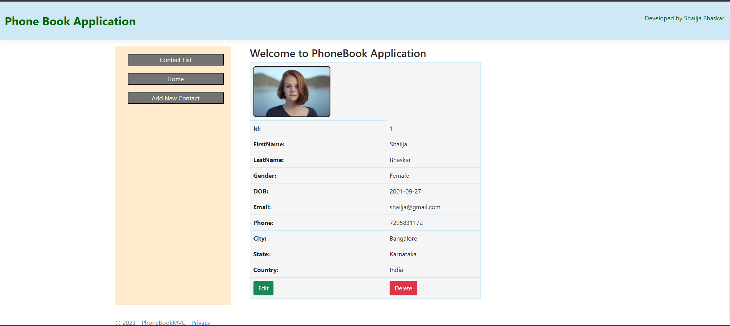

1. **Home Page(Contact List)**

This view is used to display the details of all the contacts saved in the application.

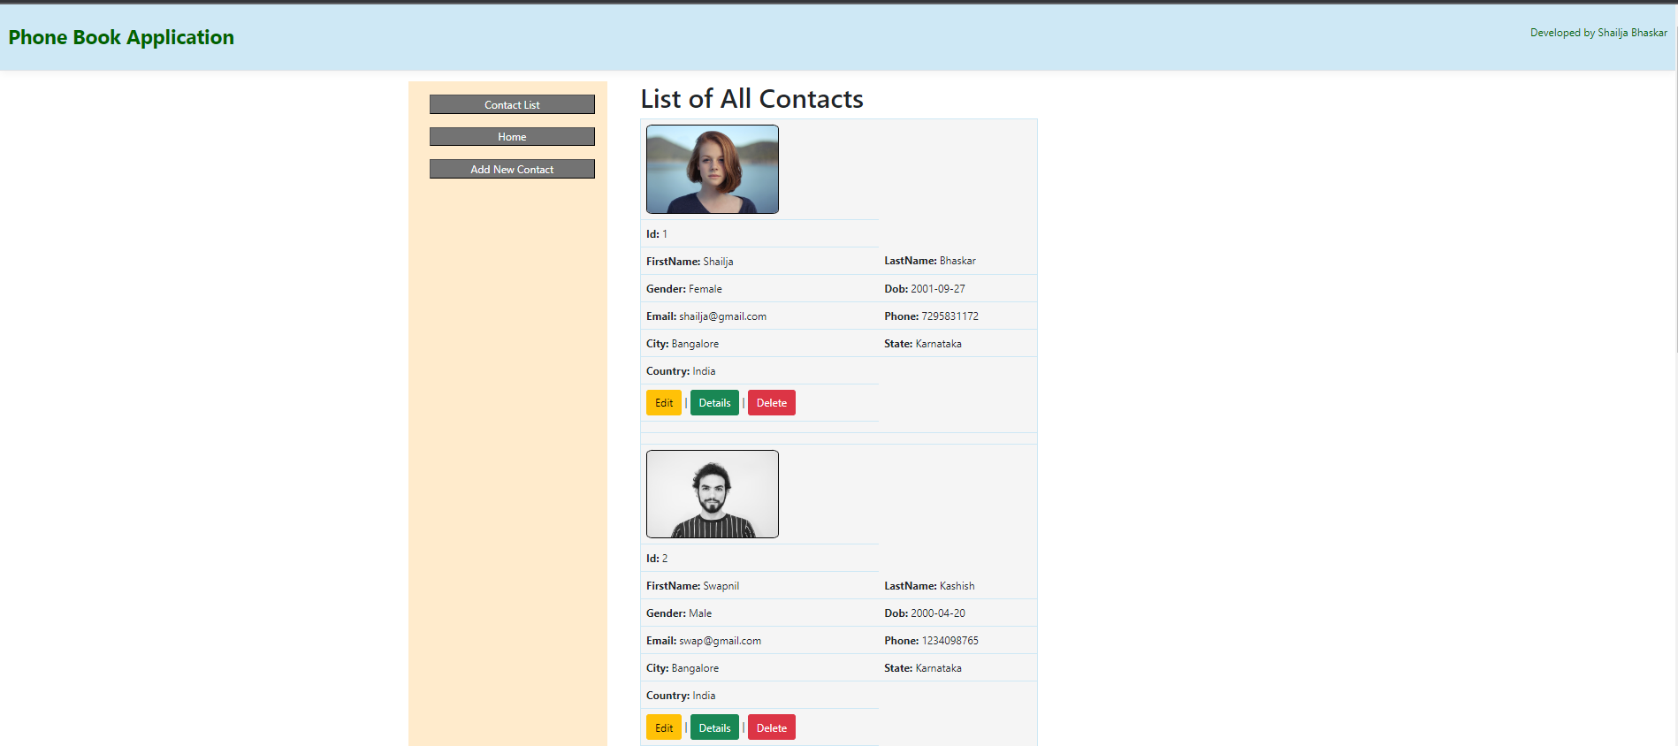

1. **Create New Contact Page**

This page creates a new contact and adds it to the contact list. It asks the user to fill a form regarding all the details along with necessary validations.

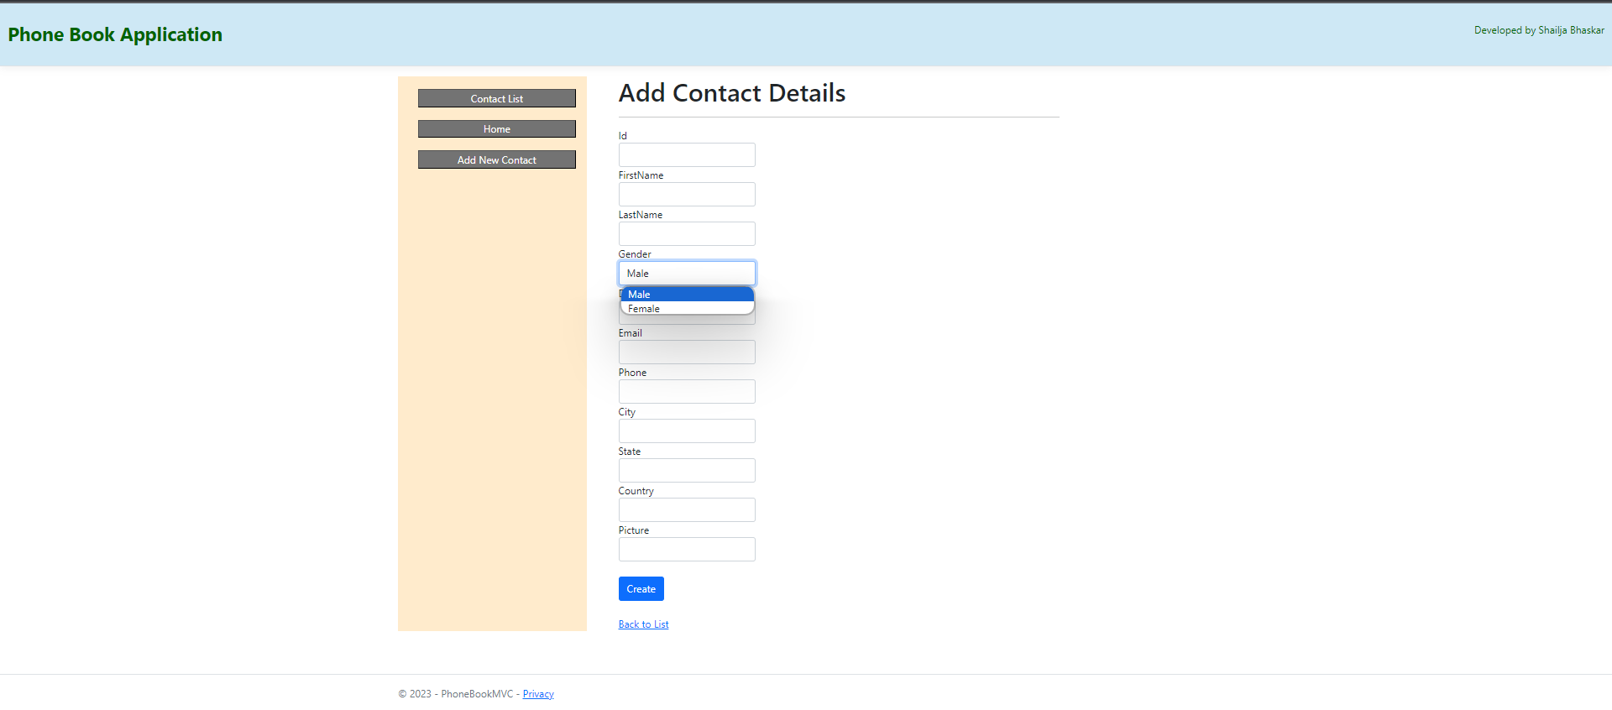

1. **Edit Page**

This page helps to edit details of a contact. For this view id is passed as parameter and then the edit method is performed.

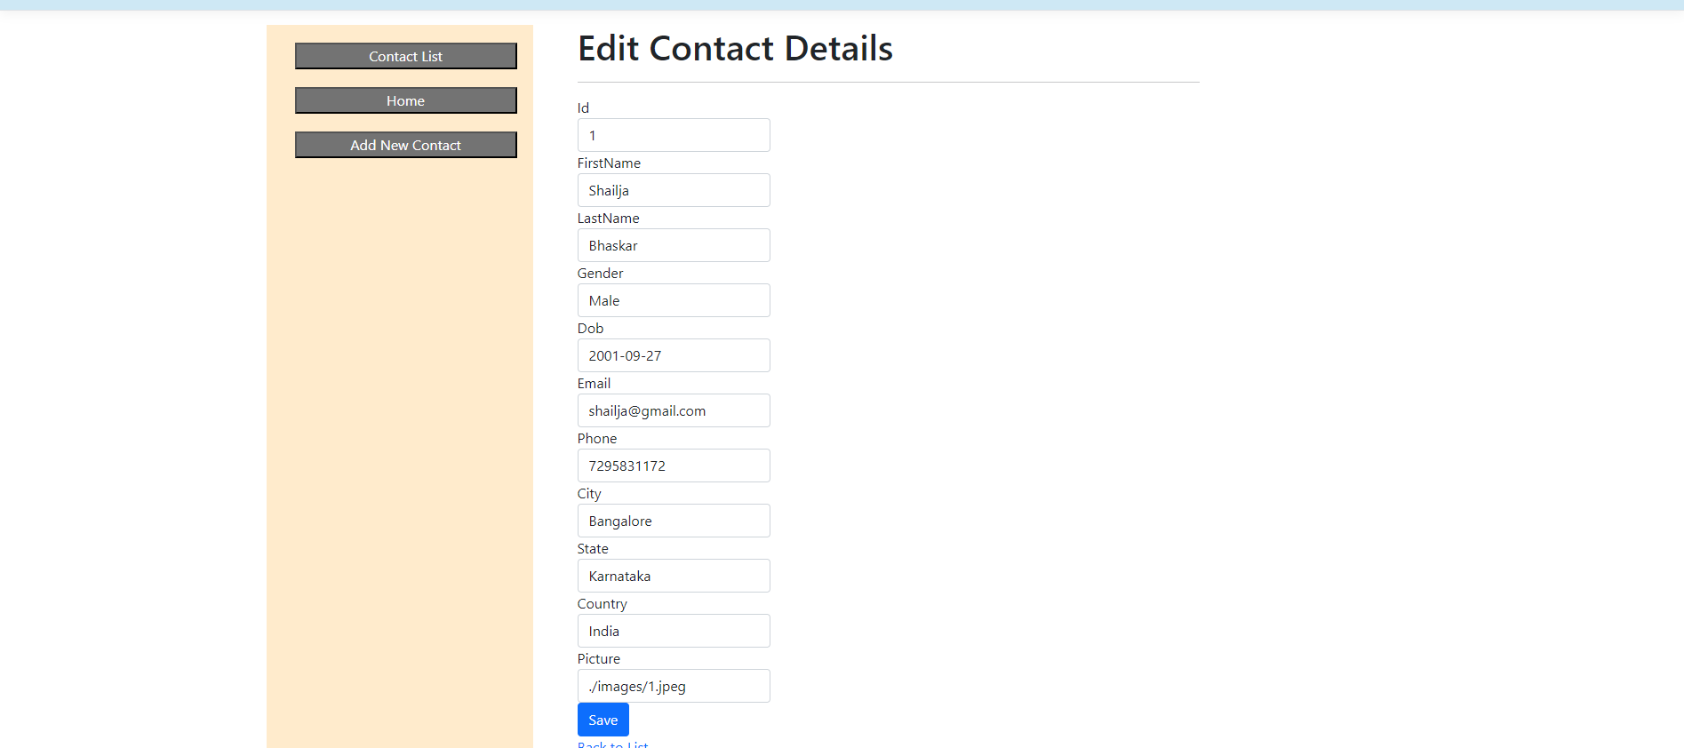

1. **Delete Contact**

This page is used to delete a specific contact based by the id.

1. **Partial View**

This part of the application is getting rendered in all other views as a result it is defined as a partial view.

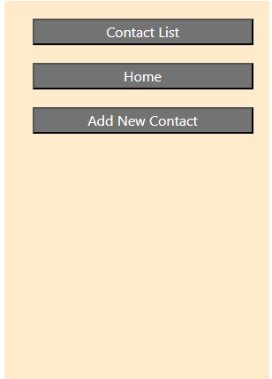

**FeedBack:**

1. UI should be user friendly.

2. Exception Handling in required methods.

3. Main Homepage should contain some button redirecting to the contact page.

4. Id should be auto incremental and should not be displayed in the details part.

5. User should have option of uploading their image instead of string input.

6. In Edit method, If any other id is passed it should display no contact exists.

7. Developed by should be in the footer.